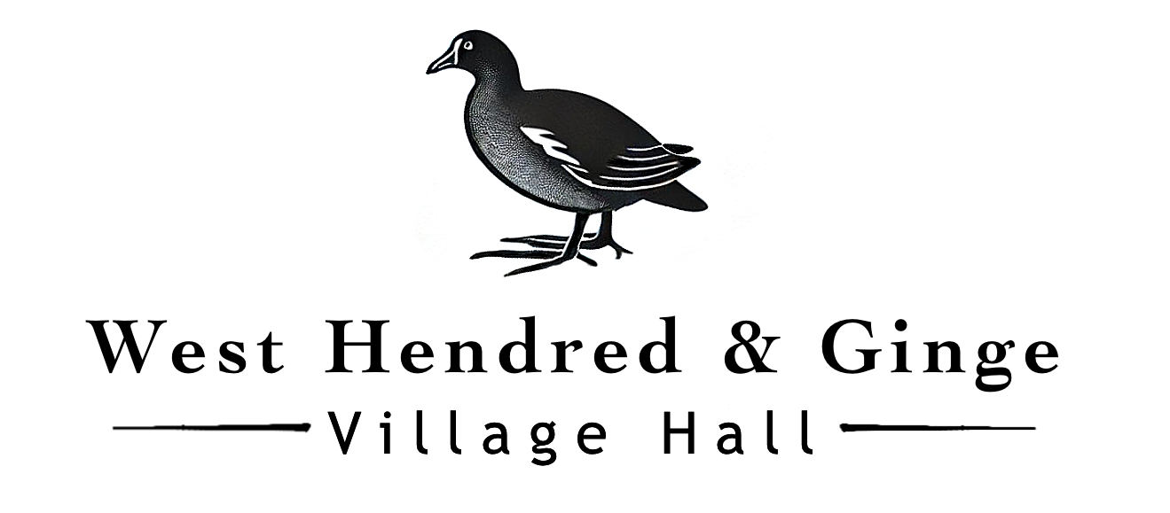
Terms and Conditions
The West Hendred Village Hall Standard Conditions of Hire
This Agreement and any non-contractual obligations arising out of or in connection with it shall be governed by, and construed in accordance with, English law.
These standard conditions apply to all hiring of The West Hendred Village Hall. If the Hirer is in any doubt as to the meaning of the following, the Booking Officer should immediately be consulted. This agreement including the online booking form constitutes the entire agreement between The West Hendred Village Hall and the Hirer.
- Supervision
The Hirer shall, during and after the period of the hiring, be responsible for: supervision of the premises, the fabric and the contents; their care, safety from damage however slight or change of any sort; and the behaviour of all persons using the premises whatever their capacity, including proper supervision of car parking arrangements so as to avoid obstruction of the highway and ensuring that no vehicle is parked on or touching the paving stones outside the Hall. The Hirer is to supervise and be available at the Hall during the entire hiring. The Hirer is responsible for ensuring the terms and conditions of hire are adhered to and that conditions in any necessary licences are conformed to. The West Hendred Village Hall Management Committee (hereafter referred to as the Management Committee) reserves the right to monitor the Hirer’s event and bring to the Hirer’s attention any matters that require control. The Hirer will address such matters immediately. As directed by the Booking Officer, the Hirer shall make good or pay for all damage (including accidental damage) to the premises, fixtures, fittings or contents and for loss of contents.
- (a) Use of Premises
The Hirer shall not use the premises for any purpose other than that described in the Hiring Agreement and shall not sub-let or use the premises or allow the premises to be used for any unlawful purpose or in any unlawful way nor do anything or bring onto the premises anything which may endanger the same or render invalid any insurance policies in respect thereof nor allow the consumption of alcohol thereon without written permission.
(b) Use of Bouncy Castles and Other Soft Play Equipment
The Hirer must not bring onto the premises a bouncy castle, or any other inflatable play equipment or soft play package, without the prior approval of the Booking Officer. For a bouncy castle this approval will only be given when the Hirer has supplied a copy of the public liability insurance policy certificate of the Hire Company supplying the equipment plus either proof that the Hire Company will be supervising use of the bouncy castle or a signed copy of the Liability Disclaimer form available on the Village Hall website. The West Hendred Village Hall and its trustees accept no responsibility for any injury, damage, or loss arising from the use of a bouncy castle or other soft play equipment. The Hirer shall ensure that all safety guidelines and supervision requirements are followed and shall indemnify The West Hendred Village Hall against any claims, costs or damages resulting from the use of the bouncy castle or other soft play equipment.
- Gaming, Betting and Lotteries
The Hirer shall ensure that nothing is done on or in relation to the premises in contravention of the law relating to gaming, betting and lotteries.
- Licence
The Hirer must comply with any license requirements on times and licence conditions if using sound amplification equipment. Please refer to https://www.gov.uk/guidance/entertainment-licensing-changes-under-the-live-music-act
- Noise
The Hirer shall ensure that minimum noise is made on arrival and departure, particularly late at night and early in the morning. The Hirer must comply with section 79 of the Environmental Protection Act 1990. The Hirer must respect the rights and needs of local residents by ensuring the Hirer and guests leave the hall and area quietly. The Hirer must not play music with hall windows or doors open. The Hirer shall, if using sound amplification equipment, comply with any other licensing condition for the premises.
- Public Safety Compliance
The Hirer shall comply with all conditions and regulations made in respect of the premises by the Fire Authority, Local Authority, the Licensing Authority or otherwise, particularly in connection with any event which constitutes regulated entertainment, at which alcohol is sold or provided or which is attended by children.
(a) The Hire shall ensure that they study the Fire Safety Instructions held in the hall lobby and understand the following matters:
The action to be taken in event of fire. This includes calling the Fire Brigade and evacuating the hall
The location and use of fire equipment
Escape routes and the need to keep them clear
Method of operation of escape door fastenings.
Appreciation of the importance of any fire doors and of closing all fire doors at the time of a fire.
(b) In advance of an entertainment or play the Hirer shall check the following items:
That all fire exits are unlocked and in good working order
That all escape routes are free of obstruction and can be safely used
That any fire doors are not wedged open
That exit signs are illuminated, if the hall lights are in use
That there are no obvious fire hazards on the premises
- Outbreak of Fire
The Fire Brigade shall be called to any outbreak of fire, however slight, and details thereof shall be given to the Secretary of the Management Committee or the Booking Officer.
- Health and Hygiene
The Hirer shall, if preparing, serving or selling food, observe all relevant food health and hygiene legislation and regulations. Food is not to be stored on the premises.
- Electrical Appliance Safety
The Hirer shall ensure that any electrical appliances brought by them to the premises and used there shall be safe, in good working order, and used in a safe manner in accordance with the Electricity at Work Regulations 1989.
- Indemnity
The Hirer shall indemnify and keep indemnified each member of the Management Committee and the Village Hall’s employees, volunteers, agents and invitees against (a) the cost of repair of any damage done to any part of the premises including the curtilage thereof or the contents of the premises (b) all claims, losses, damages and costs in respect of damage or loss of property or injury to persons arising as a result of the use of the premises (including the storage of equipment) by the Hirer, and (c) all claims, losses, damages and costs suffered or incurred as a result of any nuisance caused to a third party as a result of the use of the premises by the Hirer.
The Hirer shall take out adequate insurance to insure the Hirer and members of the Hirer’s organisation and invitees against the Hirer’s liability and all claims arising as a result of the hire and on demand shall produce the policy and current receipt or other evidence of cover to the Booking Officer. Failure to produce such policy and evidence of cover will render the hiring void and enable the Booking Officer to rehire the premises to another hirer without refund of any deposit.
The Management Committee is insured against any claims arising out of its negligence.
- Accidents and Dangerous Occurrences
The Hirer must report all accidents involving injury to the public to a member of the Management Committee as soon as possible and complete the relevant section in the Village Hall’s accident book. Any failure of equipment belonging to the Village Hall or brought in by the Hirer must also be reported as soon as possible. Certain types of accident or injury must be reported on a special form to the local authority. The Booking officer will give assistance in completing this form. This is in accordance with the Reporting of Injuries, Diseases and Dangerous Occurrences Regulations 1995 (RIDDOR).
- Explosives and Flammable Substances
The hirer shall ensure that:
(a) Highly flammable substances are not brought into, or used in any part of the premises
(b) No internal decorations of a combustible nature (e.g., polystyrene, cotton wool) shall be erected without the consent of the Management Committee. No decorations are to be put up near light fittings or heaters.
- Heating
The Hirer shall ensure that no unauthorised heating appliances shall be used on the premises when open to the public without the consent of the Management Committee. Portable Liquefied Propane Gas (LPG) heating appliances shall not be used.
- Drunk and Disorderly Behaviour and Supply of Illegal Drugs
The Hirer shall ensure that in order to avoid disturbing neighbours to the Hall and avoid violent or criminal behaviour, care shall be taken to avoid excessive consumption of alcohol. Drunk and disorderly behaviour shall not be permitted either on the premises or in its immediate vicinity. Alcohol shall not be served to any person suspected of being drunk nor to any person suspected of being under the age of 18. Any person suspected of being drunk, under the influence of drugs or who is behaving in a violent or disorderly way shall be asked to leave the premises. No illegal drugs may be brought onto the premises.
- Animals
The Hirer shall ensure that no animals (including birds) except guide dogs are brought into the premises, other than for a special event agreed to by the Management Committee. No animals whatsoever are to enter the kitchen at any time.
- Compliance with The Children Act 1989
The Hirer shall ensure that any activities for children under eight years of age comply with the provisions of The Children Act of 1989 and that only fit and proper persons who have passed the appropriate Criminal Records Bureau checks have access to the children (checks may also apply where children over eight and vulnerable adults are taking part in activities). The Hirer shall provide the Management Committee with a copy of their Safeguarding Policy on request.
- Fly Posting
The Hirer shall not carry out or permit fly posting or any other form of unauthorised advertisements for any event taking place at the premises and shall indemnify and keep indemnified The West Hendred Village Hall accordingly against all actions, claims and proceedings arising from any breach of this condition. Failure to observe this condition may lead to prosecution by the local authority.
- Sale of Goods
The Hirer shall, if selling goods on the premises, comply with Fair Trading Laws and any code of practice used in connection with such sales. In particular, the Hirer shall ensure that the total prices of all goods and services are prominently displayed, as shall be the organiser’s name and address and that any discounts offered are based only on Manufacturers’ Recommended Retail Prices.
- Cancellation
If the Hirer wishes to cancel the booking within one week of the date of the event, repayment of the hire charge shall be at the discretion of the Management Committee. The Management Committee reserves the right to cancel this hiring by written notice (including email) to the Hirer in the event of:
(a) the premises being required for use as a Polling Station for a Parliamentary or Local Government election or by-election.
(b) the Management Committee reasonably considering that (i) such hiring will lead to a breach of licensing conditions, if applicable, or other legal or statutory requirements, or (ii) unlawful or unsuitable activities will take place at the premises as a result of this hiring.
(c) the premises becoming unfit for the use intended by the Hirer.
(d) an emergency requiring use of the premises as a shelter for the victims of flooding, snowstorm, fire, explosion or those at risk of these or similar disasters.
(e) any government restrictions in place at the time of the Hirer’s event
In any such case the Hirer shall be entitled to a refund of any deposit or hire charge already paid, but The West Hendred Village Hall shall not be liable in any way to the Hirer for any resulting direct or indirect loss or damages whatsoever.
- End of Hire Requirements
The Hirer shall be responsible for leaving the premises and surrounding area in a clean and tidy condition, properly locked and secured unless directed otherwise and any contents temporarily removed from their usual positions properly replaced, otherwise the Village Hall shall be at liberty to make an additional charge or retain any damages deposit.
- Stored Equipment
The West Hendred Village Hall accepts no responsibility for any stored equipment or other property brought on to or left at the premises and all liability for loss or damage is hereby excluded. All equipment and other property (other than stored equipment) must be removed at the end of each hiring or may be disposed of unless left with prior agreement with the Booking Officer
- No Alterations
No alterations or additions may be made to the premises nor may any fixtures be installed or placards, decorations or other articles be attached in any way to any part of the premises without the prior written approval of the Booking Officer. Any alteration, fixture or fitting or attachment so approved shall be removed at the end of the hiring, without damage to the premises by such removal, to the satisfaction of the Management Committee or, at the discretion of the Management Committee, shall become the property of the Village Hall.
- No Rights
The Hiring Agreement constitutes permission only to use the premises and confers no tenancy or other right of occupation on the Hirer.
- Force Majeure
No Party shall be liable or responsible to the other Party, nor be deemed to have defaulted under or breached this Agreement, for any failure or delay in fulfilling or performing any term of this Agreement (except for any obligations to make previously owed payments to the other Party hereunder) when and to the extent such failure or delay is caused by or results from acts beyond the impacted Party’s (“Impacted Party”) reasonable control, including, without limitation, the following Force Majeure event/s that frustrates the purpose of this Agreement: (a) acts of God; (b) flood, fire, earthquake or explosion; (c) war, invasion, hostilities (whether war is declared or not), terrorist threats or acts, riot or other civil unrest; (d) government order or law; (e) actions, embargoes or blockades in effect on or after the date of this Agreement; (f) action by any governmental authority; (g) national or regional emergency; (h) strikes, labour stoppages or slowdowns or other industrial disturbances; (i) epidemic, pandemic or similar influenza or bacterial infection (j) other similar events beyond the reasonable control of the Impacted Party.
- Severability
In the event any provision of this agreement shall be invalid, illegal or unenforceable in any respect, such provision shall be considered separate and severable from the remaining provisions of this agreement, and the validity, legality or enforceability of any of the remaining provisions of this agreement shall not be impaired by such provision in any way.

